FIELD REPORT
Introduction
- Place:KOLE SEED SECONDARY SCHOOL
- Location: Kole district
- Date of visit: 26th August 2026

1. General observations
Some of the furniture was engraved whereas others were not.
The table below illustrates some physical status of the verified assets with photographic evidence.
Table XXX: Physical verification photos
SCIENCE LABOLATORY BLOCK WITH TWO UNITS | 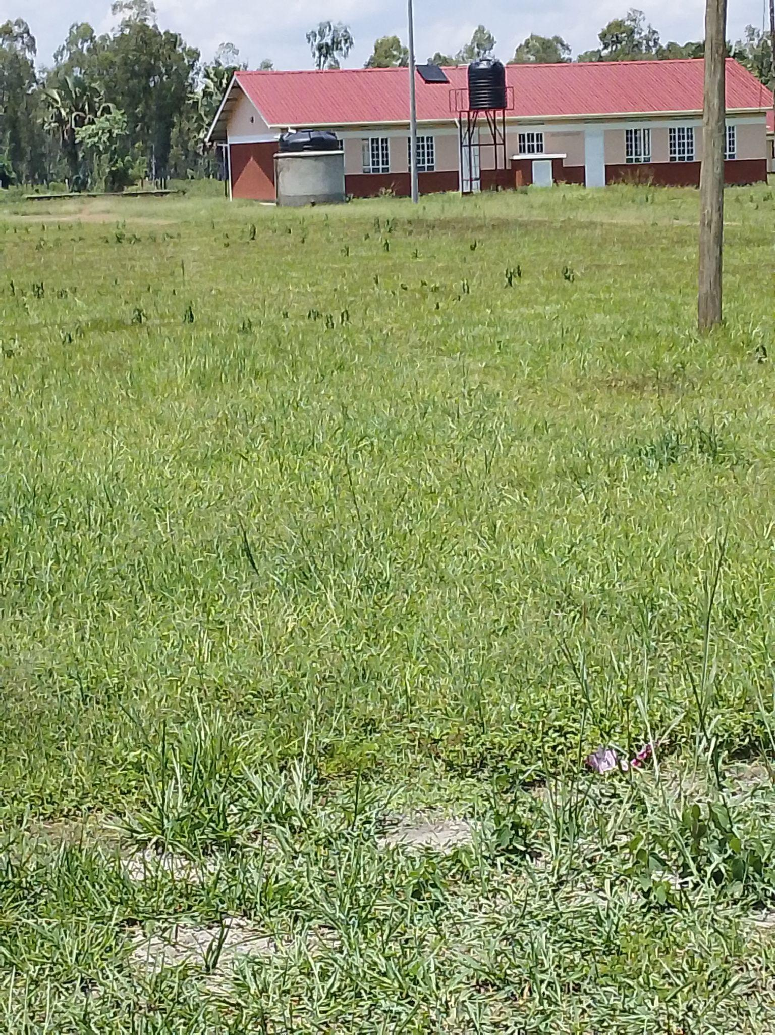
ADMINISTRATION BLOCK WITH TWO UNITS | 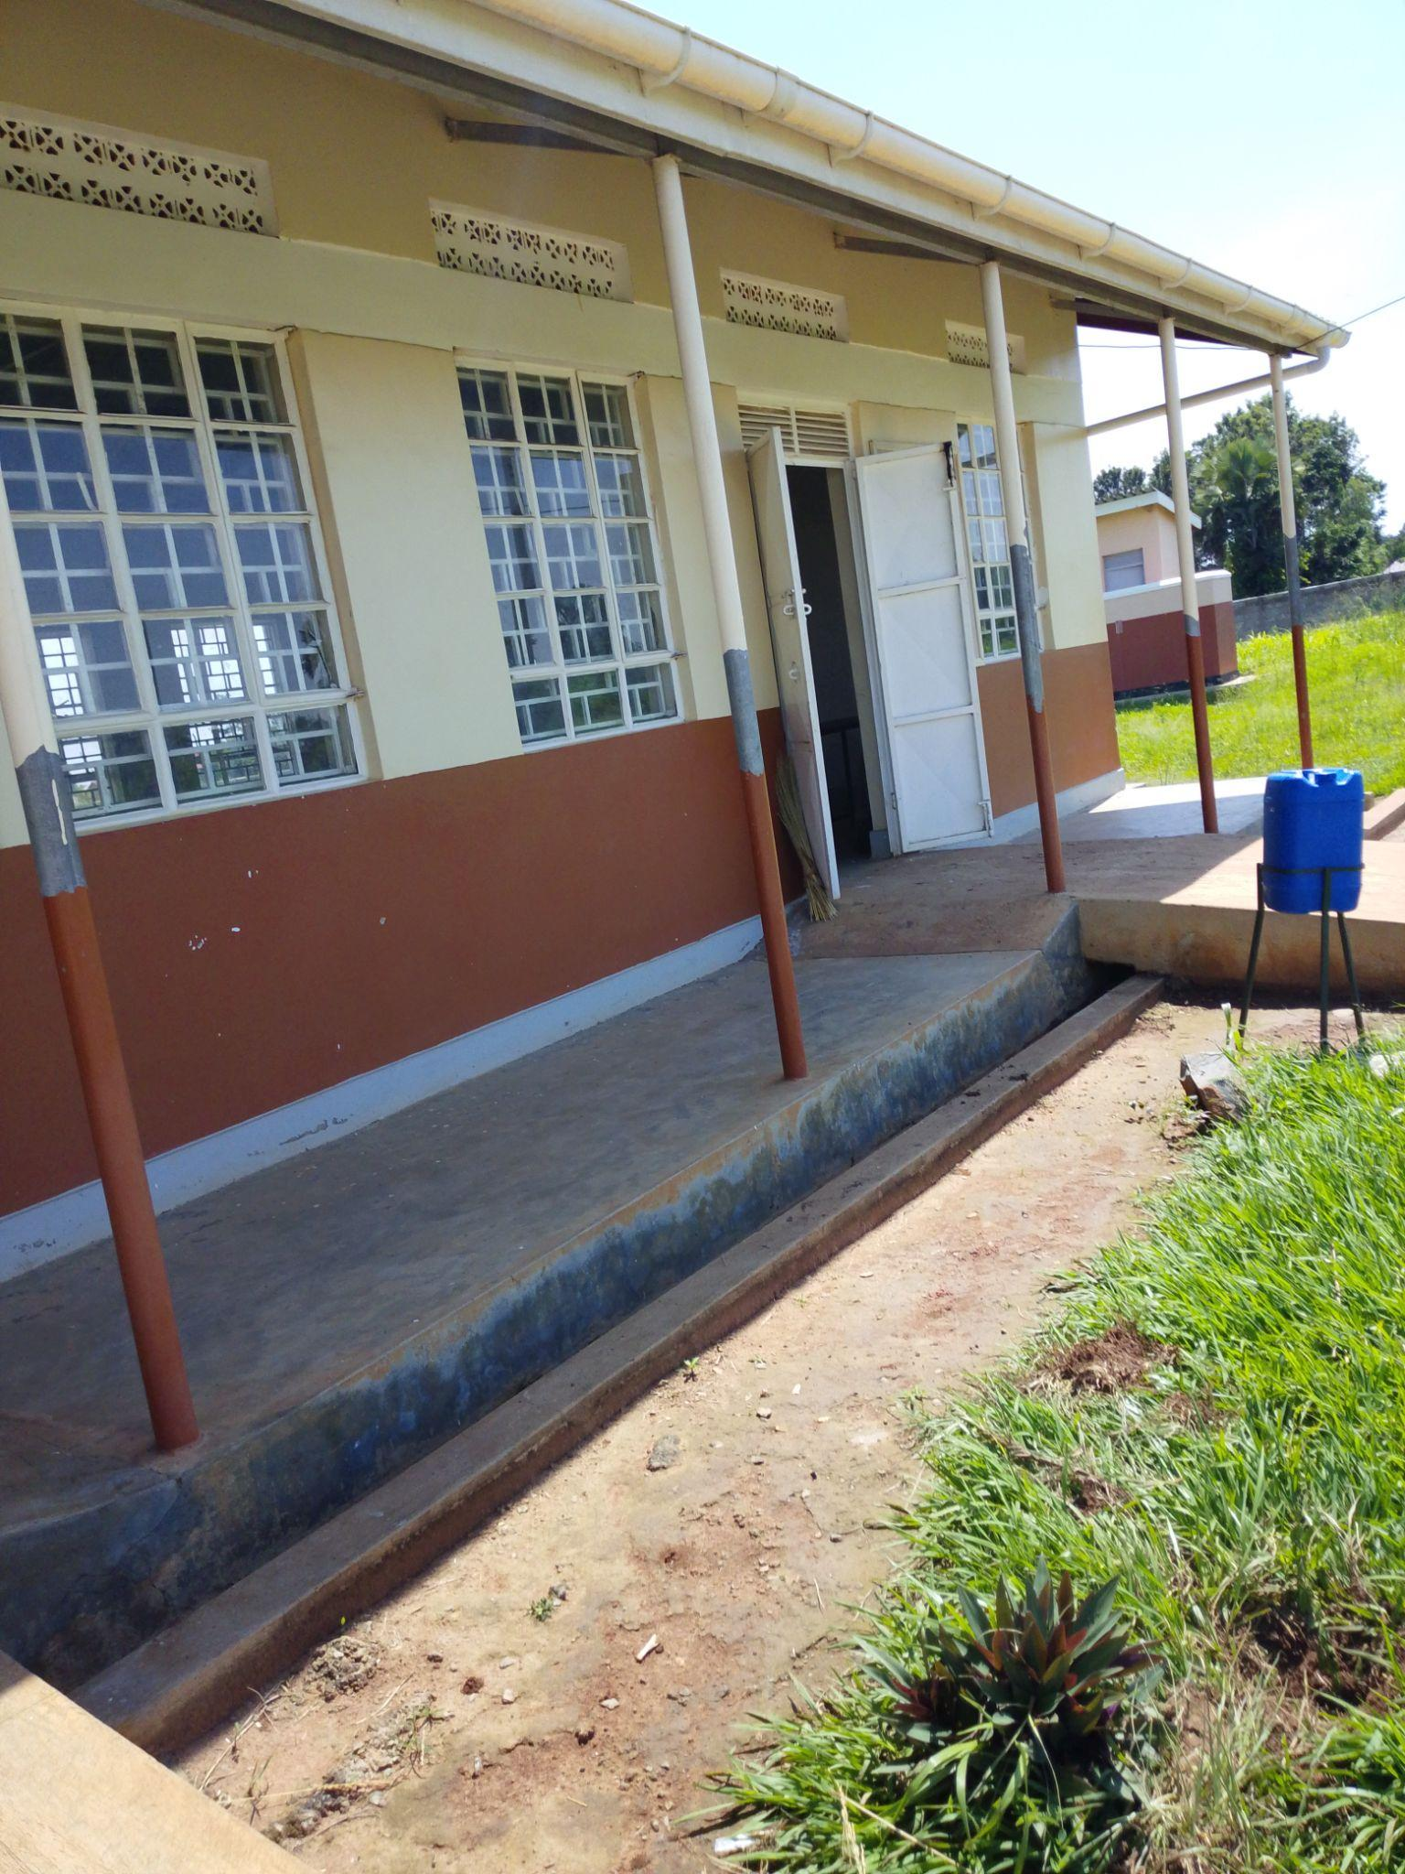
ICT /LIBRARY BLOCK | 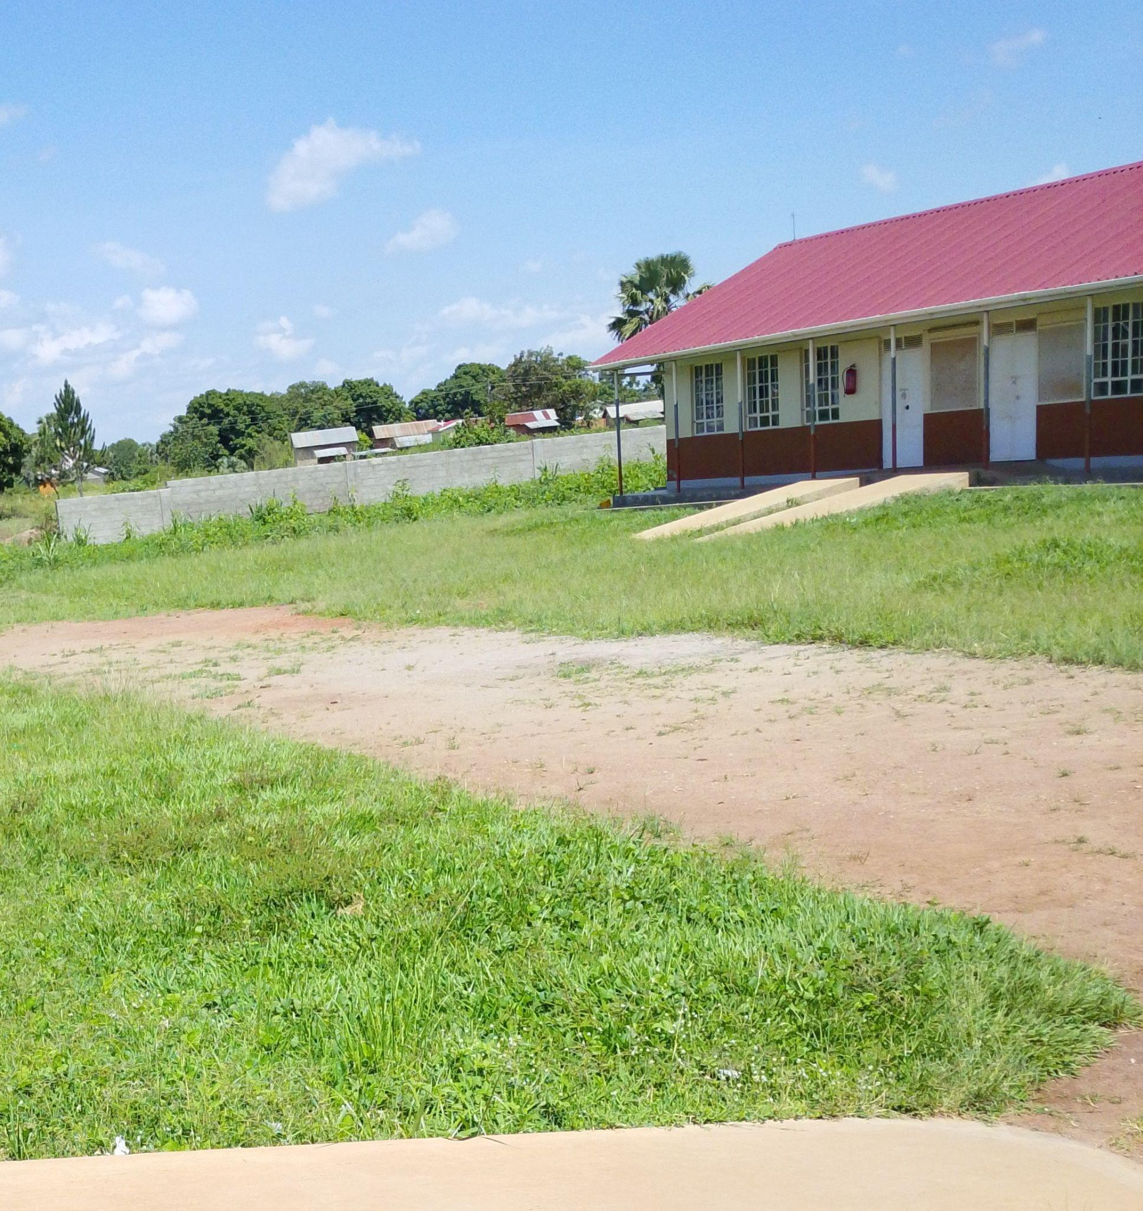
10,000LTRS HDPE CREST TANK WHICH FEEDS A 3,00OLTRS ELEVATED HDPE TANK WITH A PUMP | 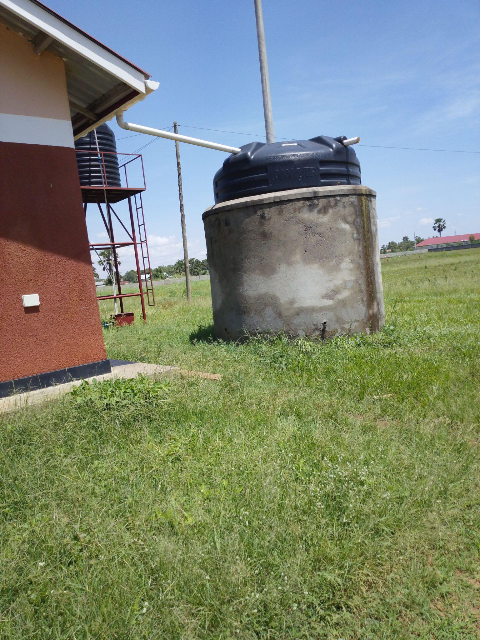
TYPICAL TWO UNITS CLASSROOM BLOCK | 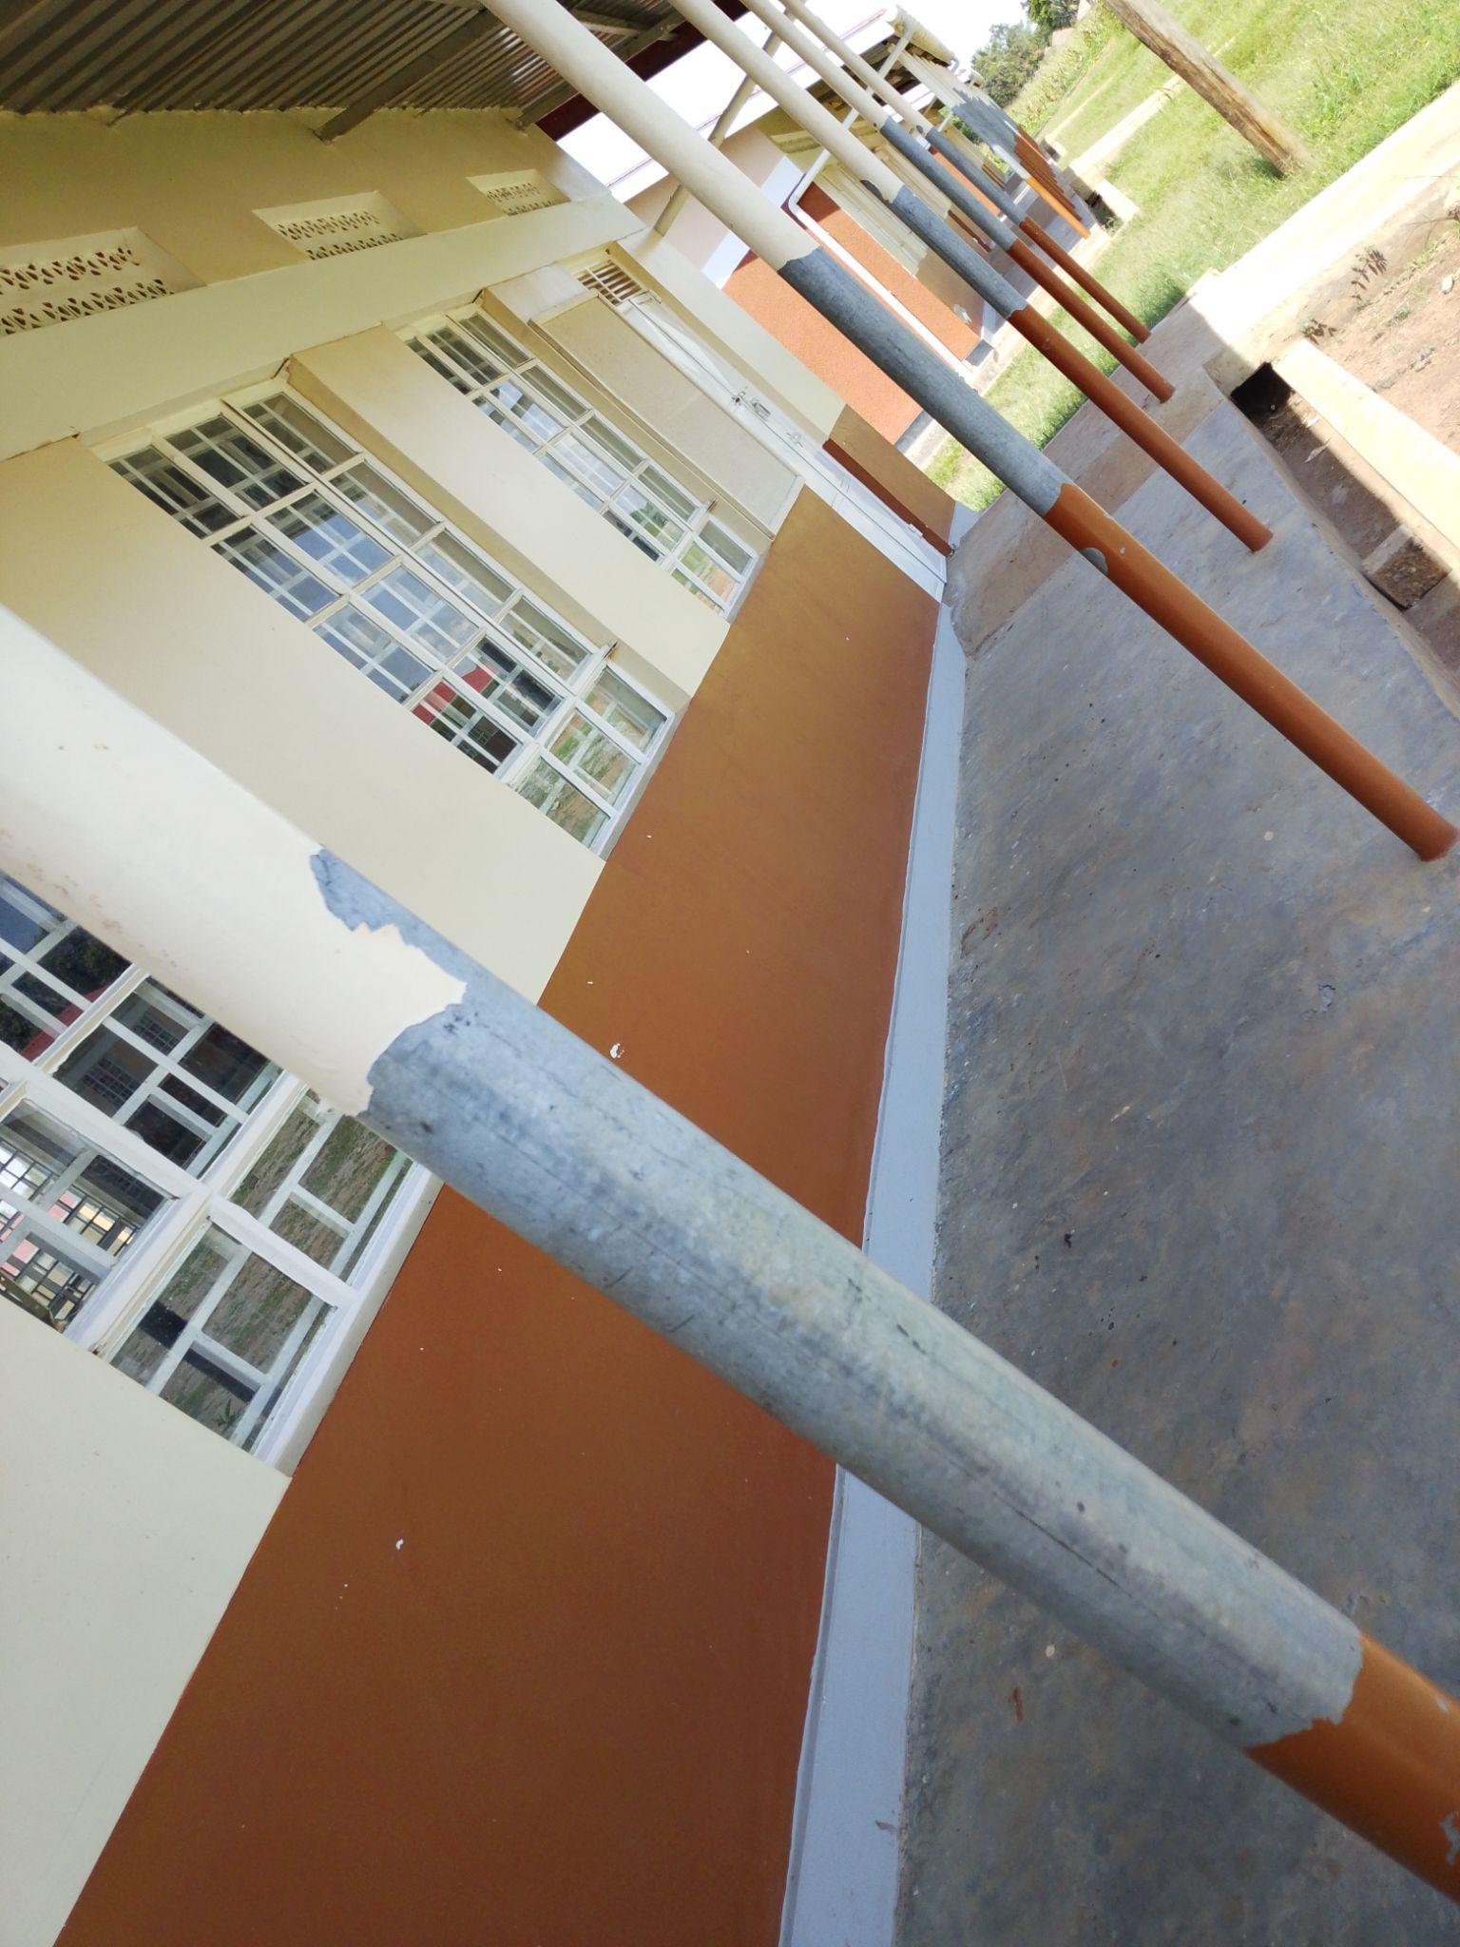
TYPICAL 5 STANCE VIP PIT LATRINE BLOCK | 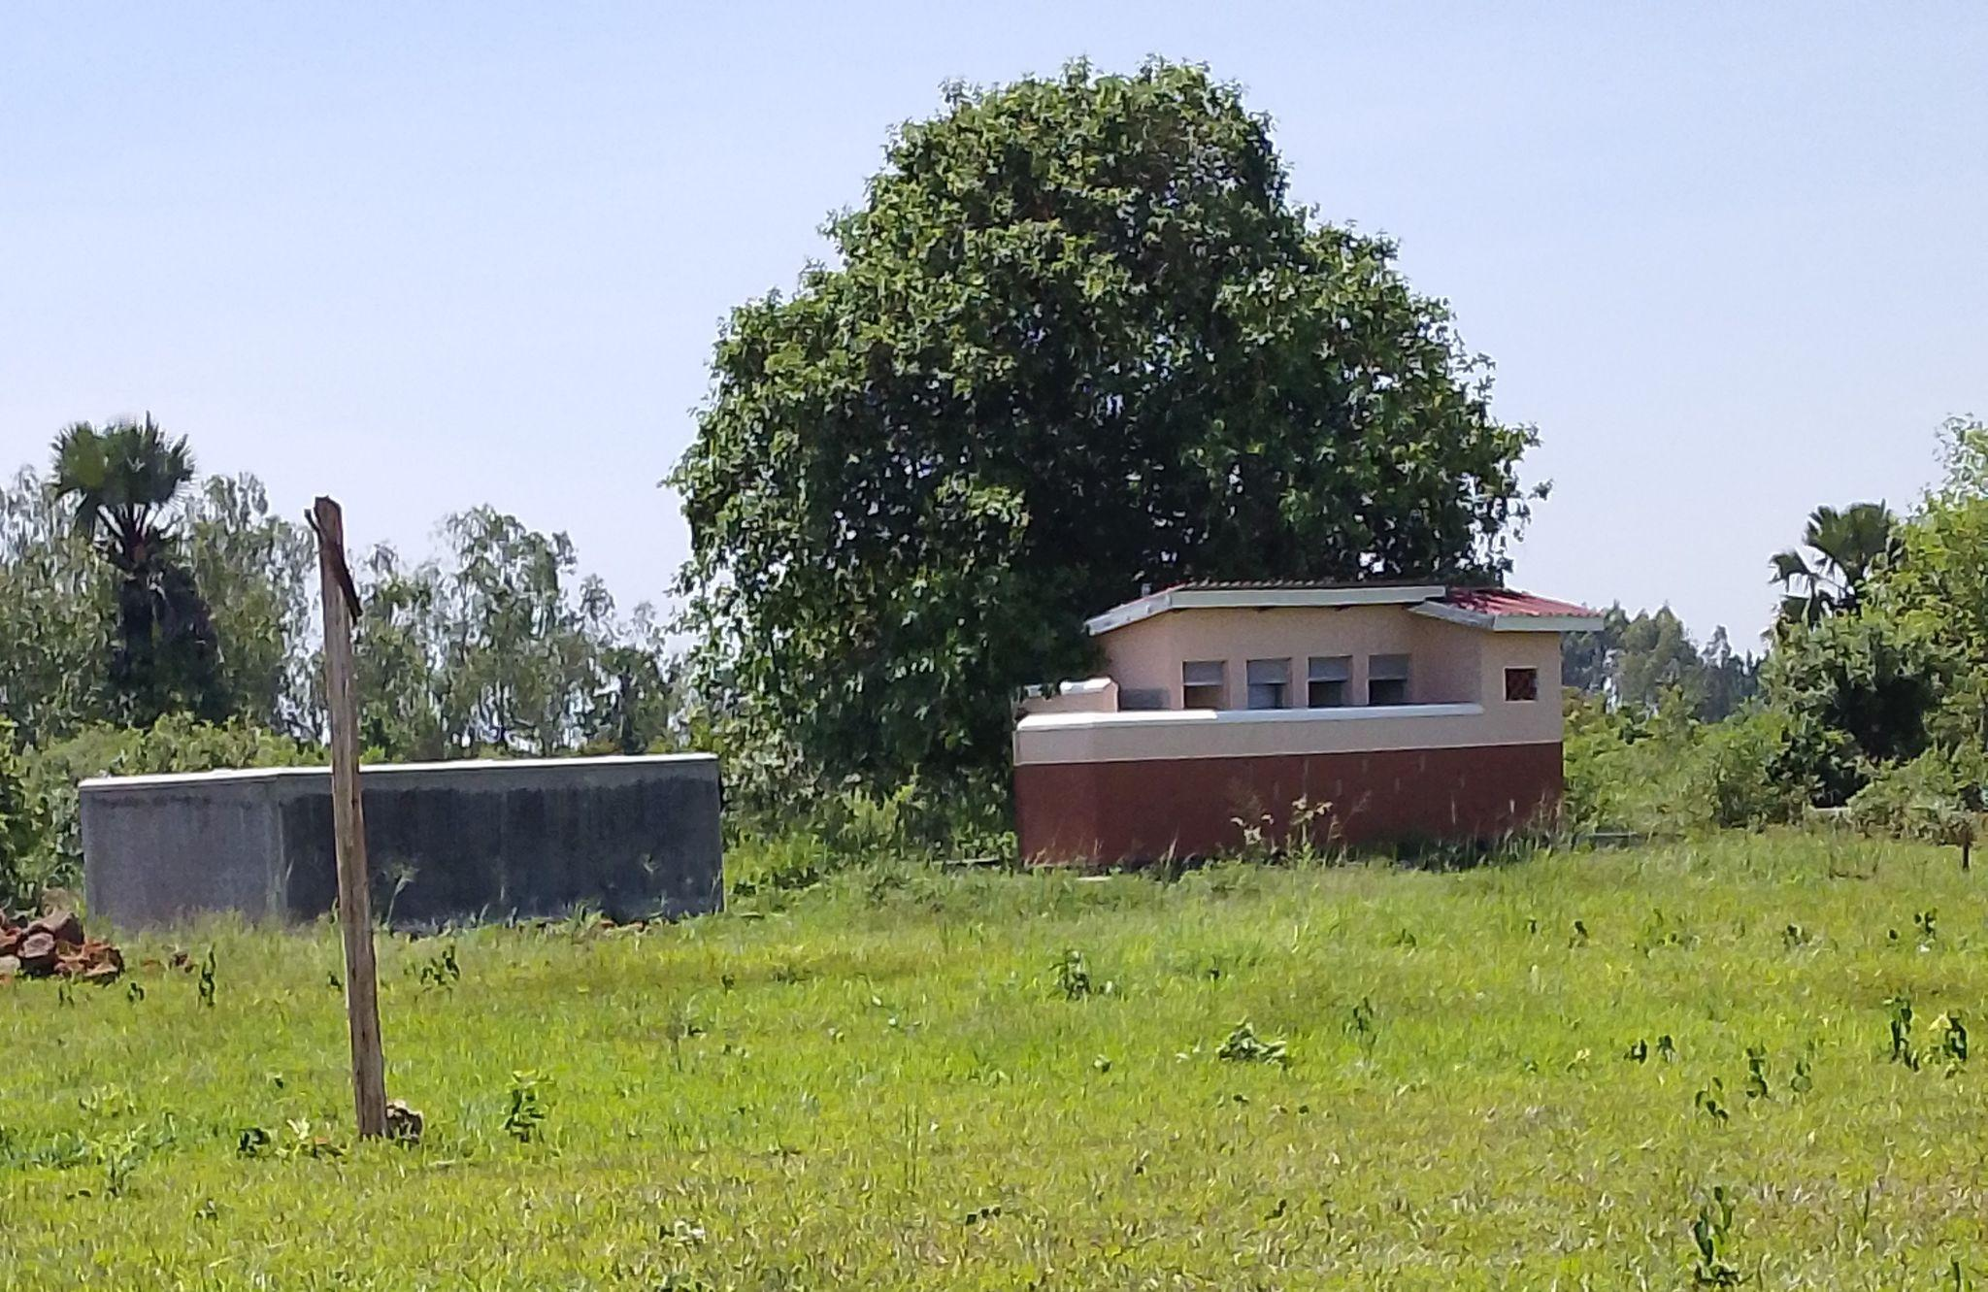
ACER PROJECTOR | 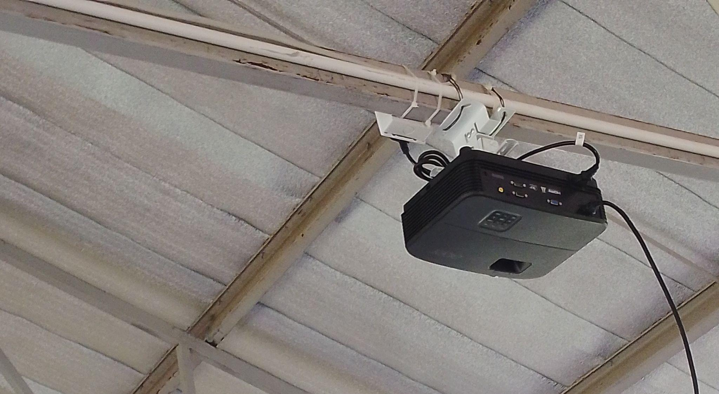
COMPUTER SET (MONITOR, UPS, POWER) | 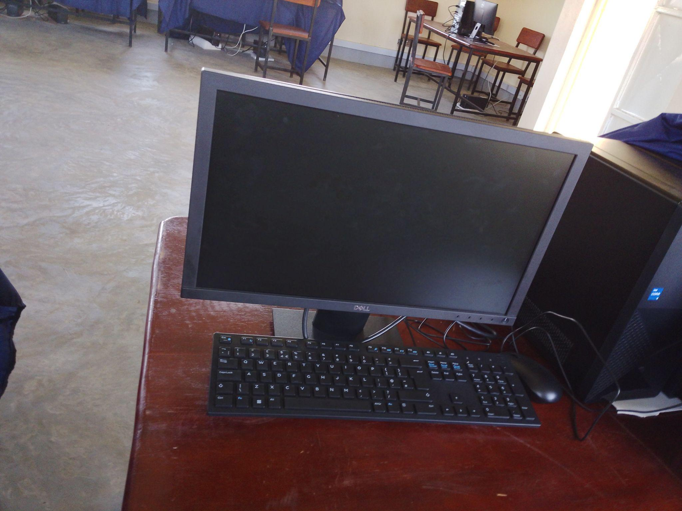
UPS | 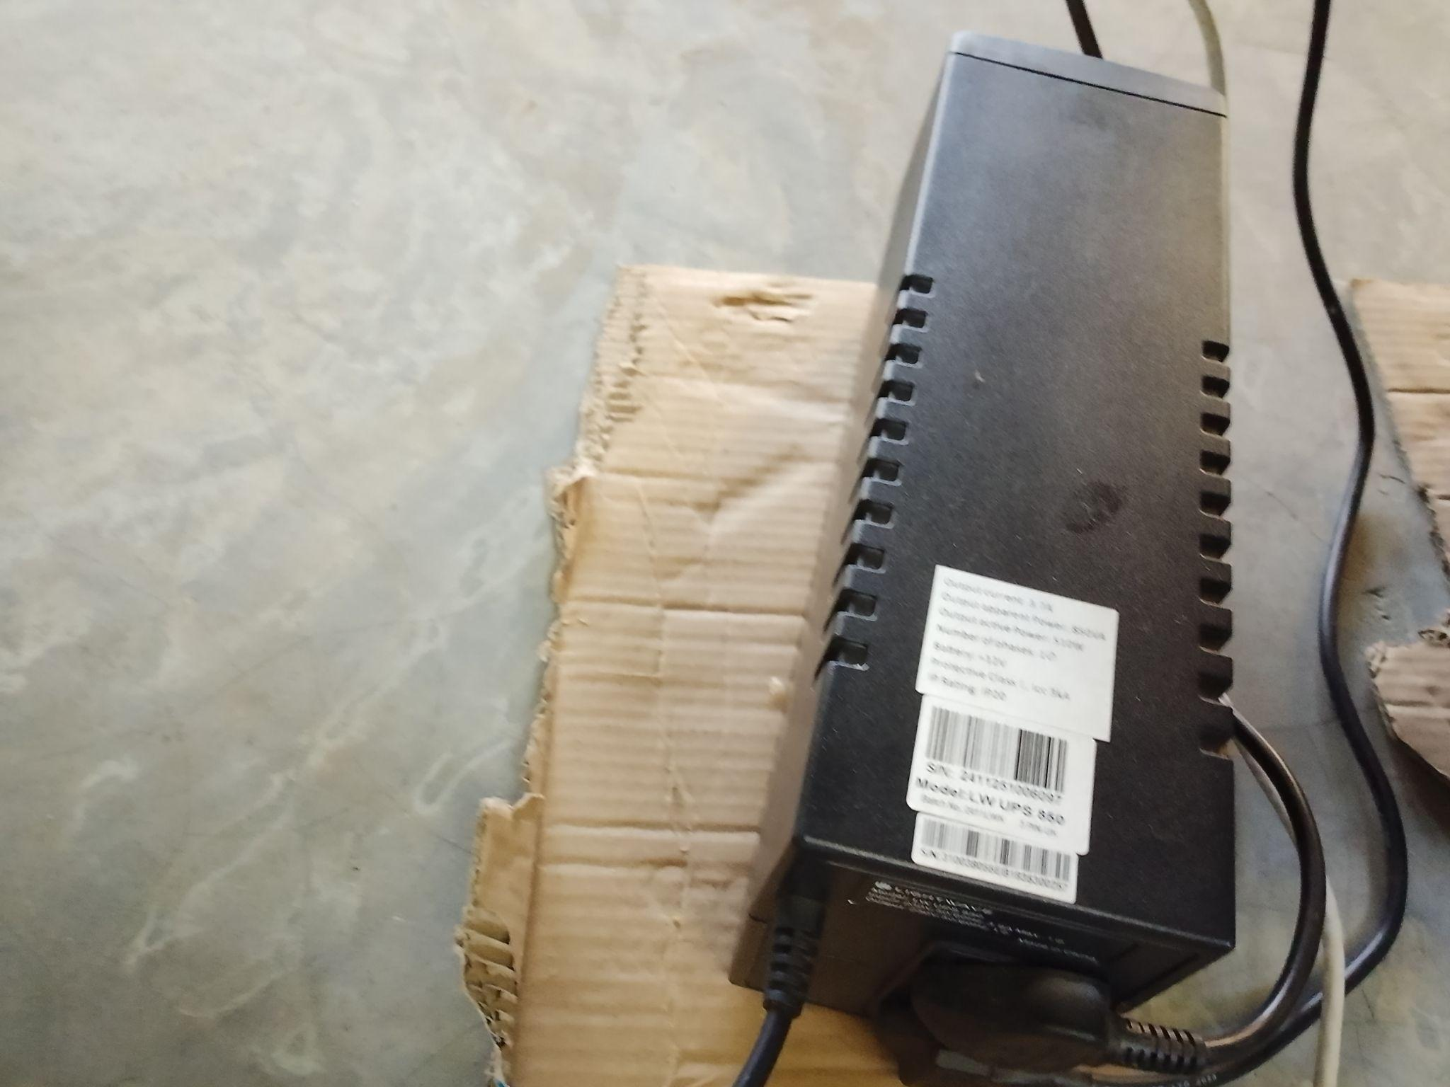
CCT CAMERA-ONE EYE | 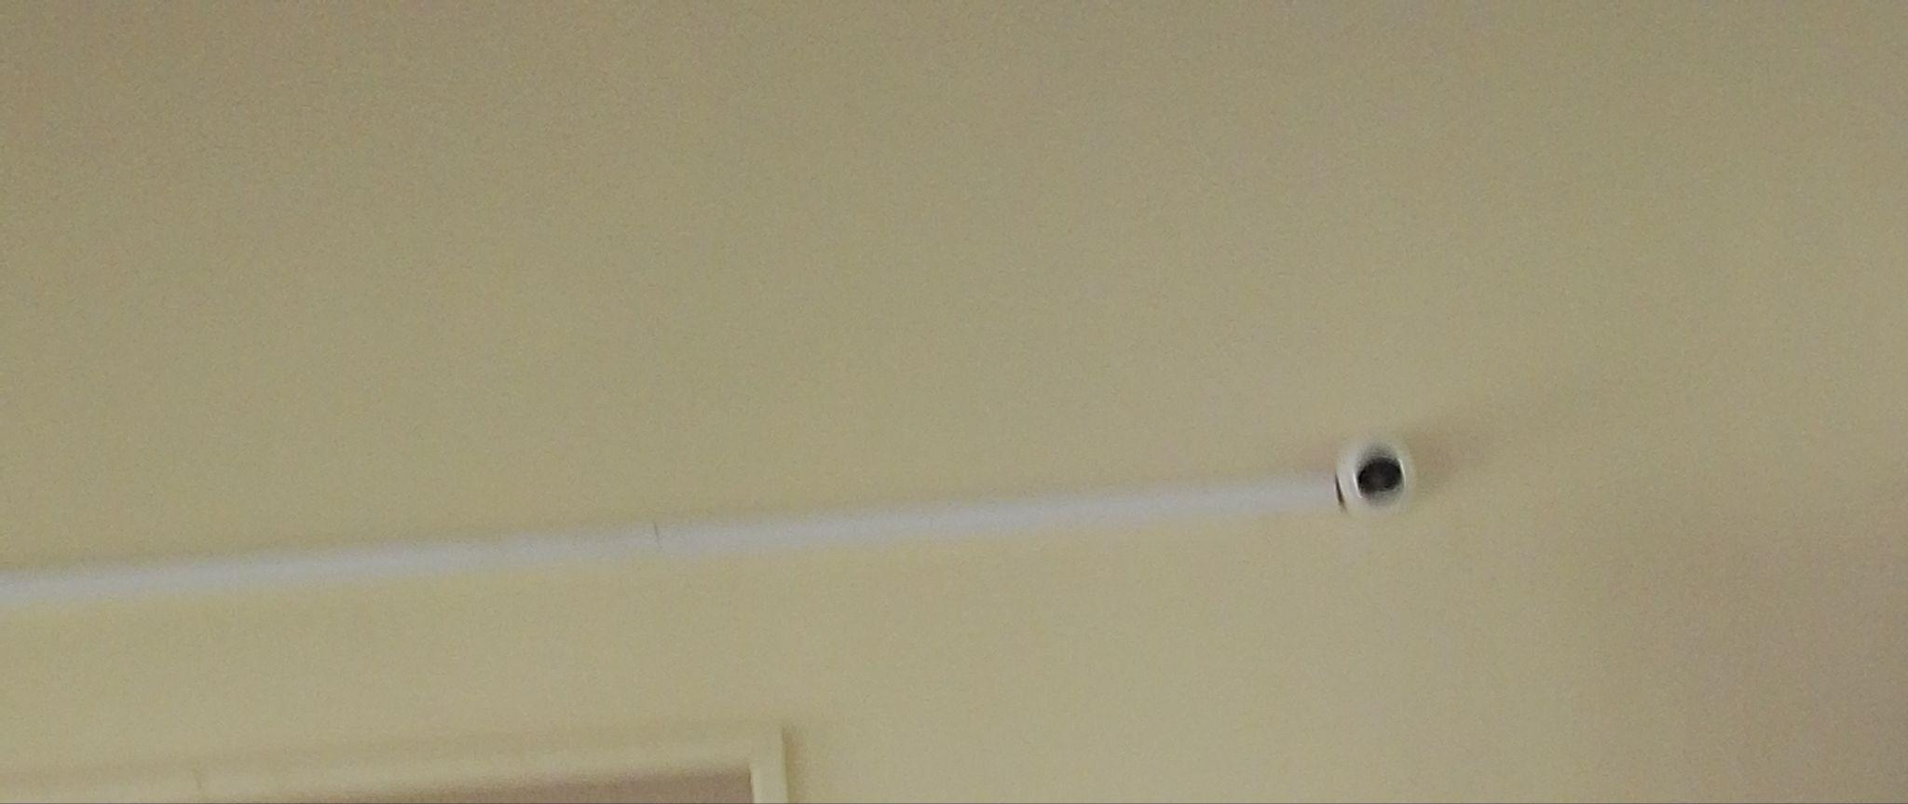
WALL LABORATORY TABLE WITH SHUTTERS, AND SINKS AND WATER CONNECTION | 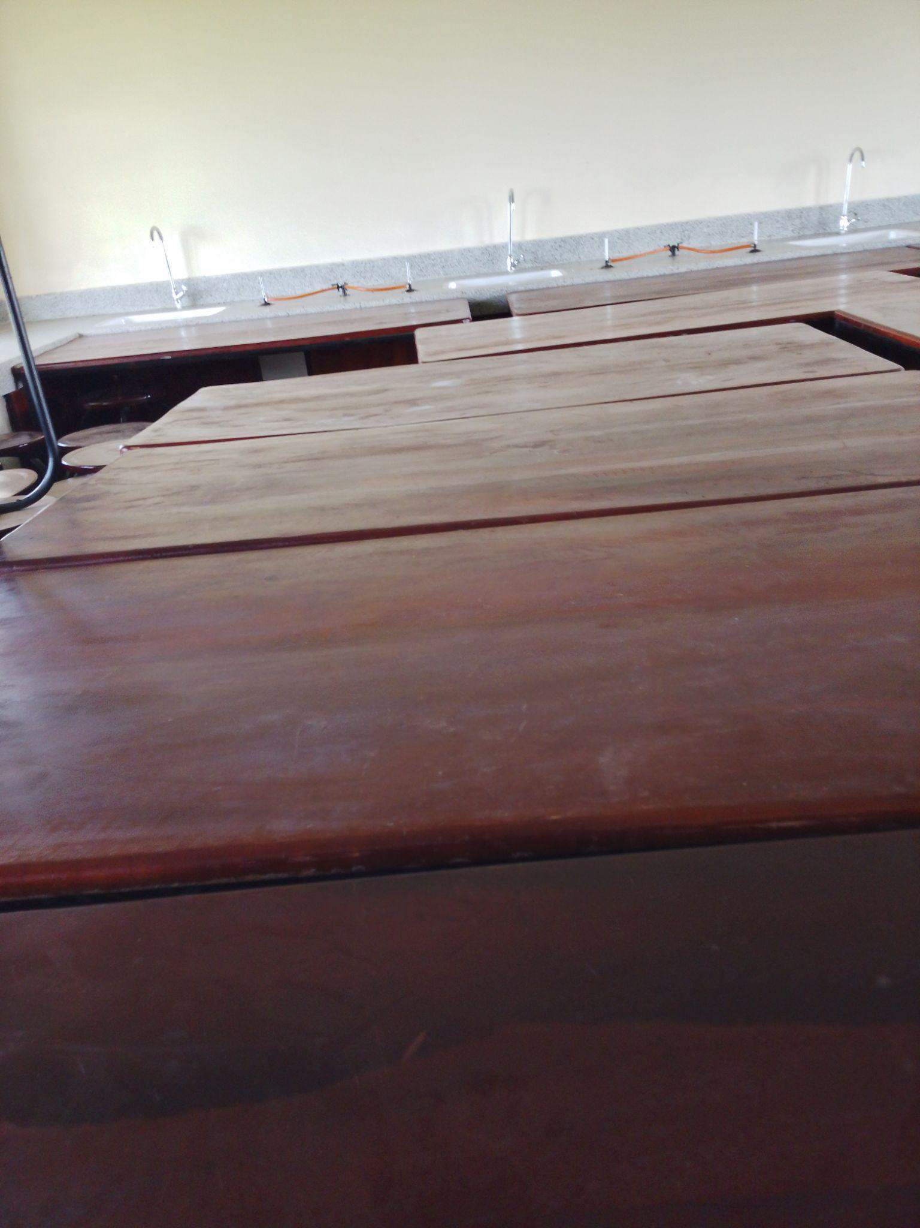
SAMPLE OF LAORATORY STOOLS | 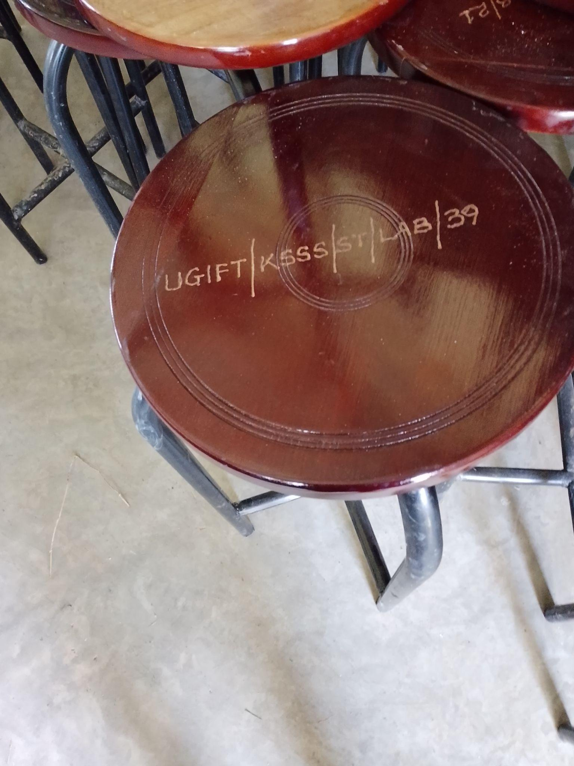
SAMPLE OF CHAIRS, ENGRAVED | 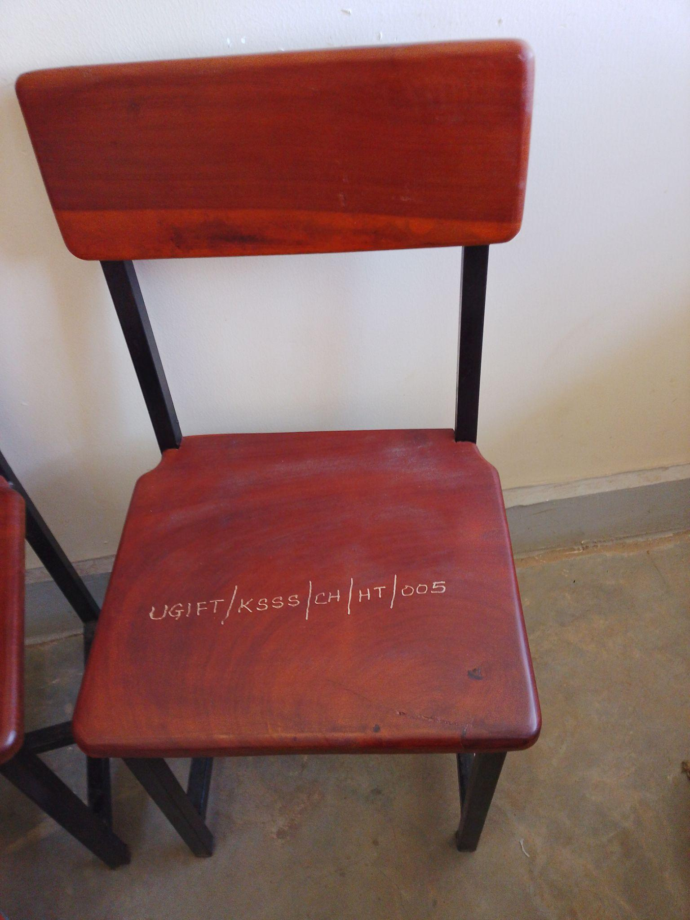
CHAIRS | 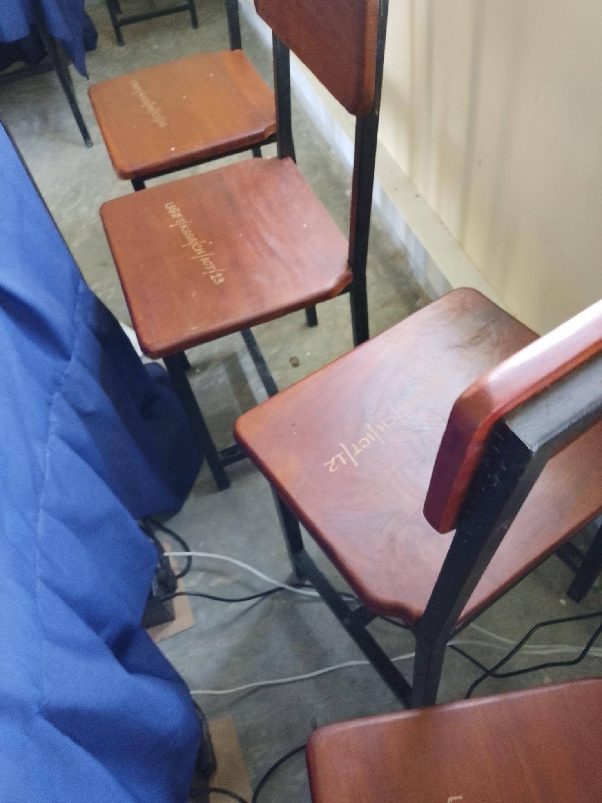
LIBRARY BOOK SHELVES, TABLES, AND CHAIRS | 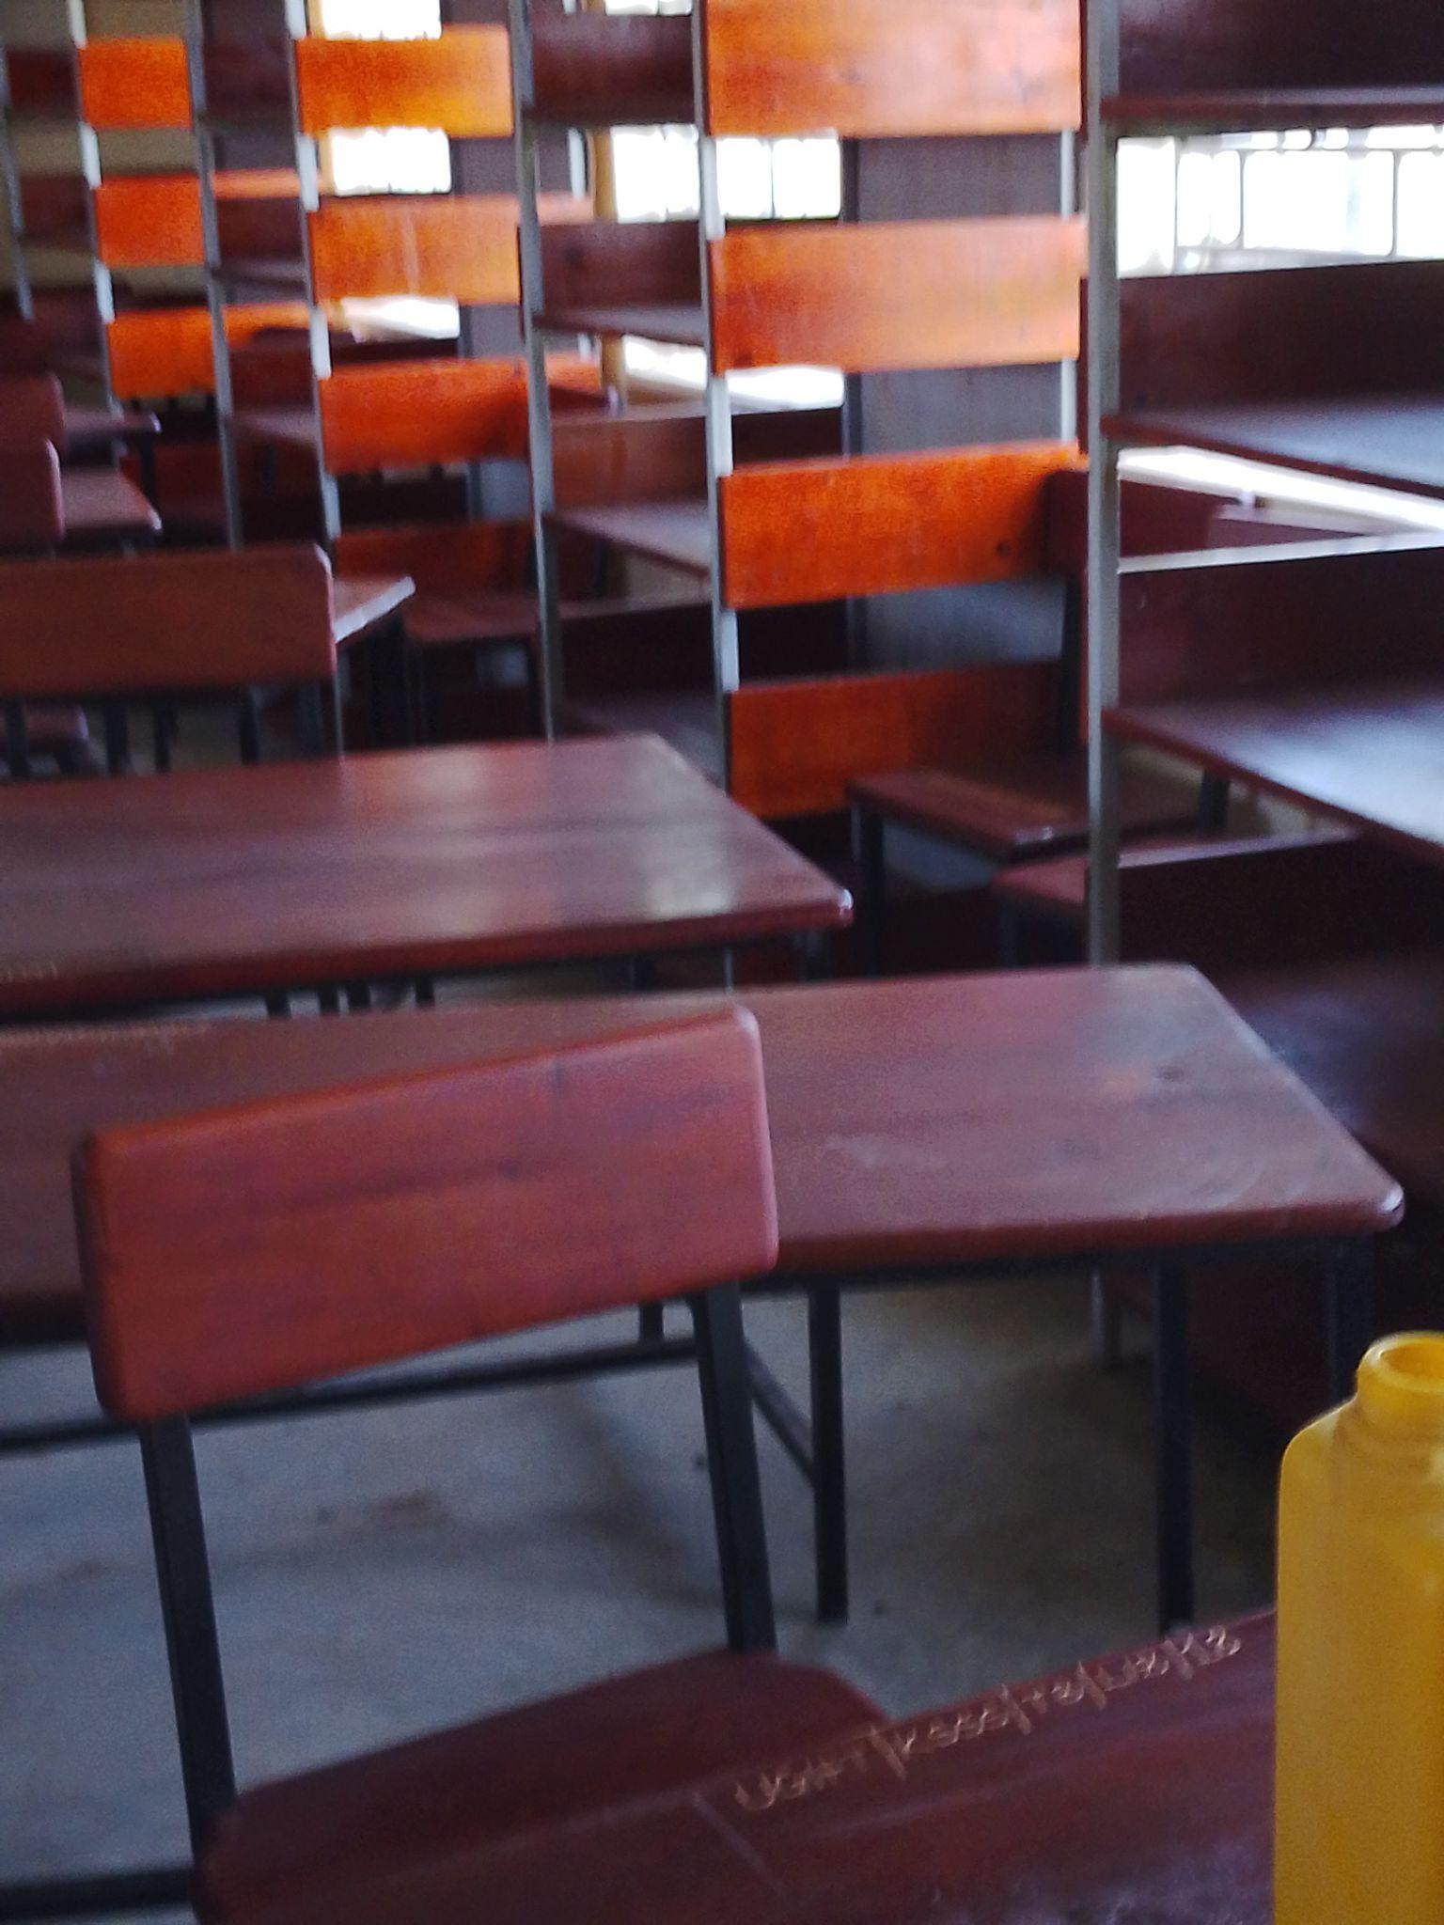
INTERIOR OF THE COMPUTER LABORATORY | 